Teacher Kara Weyhenmeyer  Elem. PLC | Date  5.15 |  | Grade  3-5 |  | Content Area  Math: Numbers and Operations in Base Ten; Operations and Algebraic Thinking  - Patterns
Objective/Essential Question:  Did you learn how to complete a pattern today?  - Physical Skills:  Each student will participate to the extent of their physical abilities of the lesson. They will practice not only gross motor but fine motor skills by activating switches, reaching for materials and interacting with peers and classroom staff.  - Cognitive Skills:  Symbolic: Increase understanding of words with similar phonetic meaning, Continue to increase vocabulary. Demonstrate sustained interaction with text. Continue to demonstrate personal experiences to connect with text, Identify target words within text. Demonstrate comprehension of text read to them and apply what is learned to everyday life.  Early Symbolic: Choose text for exploration. Increase vocabulary. Demonstrate sustained attention to text. Demonstrate an association between symbols and their meaning.  Pre-Symbolic: Demonstrate awareness of new and routine vocabulary. Demonstrate awareness of and/or response to text being read aloud. Demonstrate attention to instructional materials in a literacy context, Demonstrate a preference for a text  - Social Skills (learning teams):  The students will have the opportunity to interact with peers not only during whole group instruction but also in small group. |  |  |  |  |  |  |  | Plan for Differentiation:  Using Bloom’s Revised Taxonomy  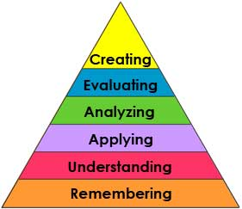
Materials
Smartboard
Picture symbols
Printed material
Scissors, glue, pencil
AAC devices

Vocabulary (Literacy)
Pattern

Technology
Smartboard
Variety of AAC devices
iPad –upload various pictures using Choice Board Creator (optional)

Curriculum Standard
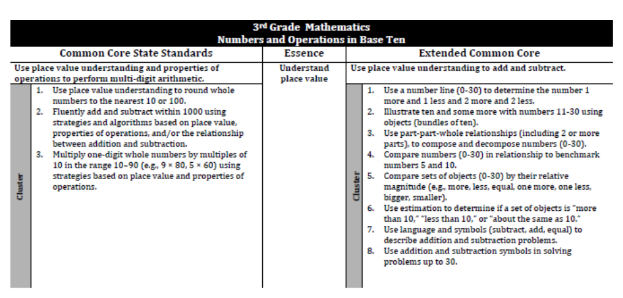
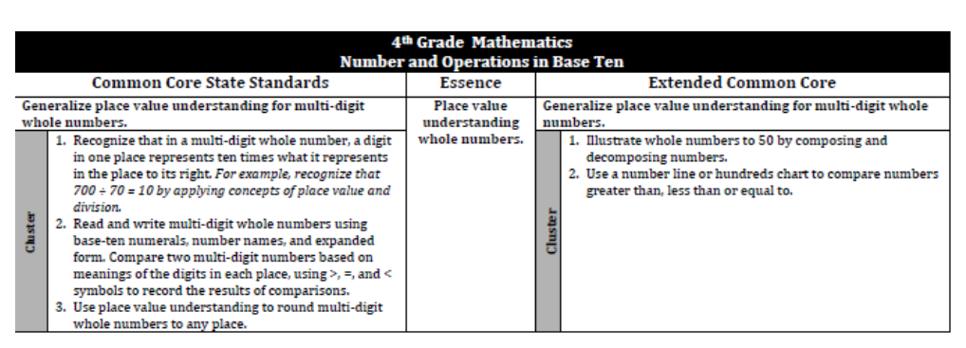
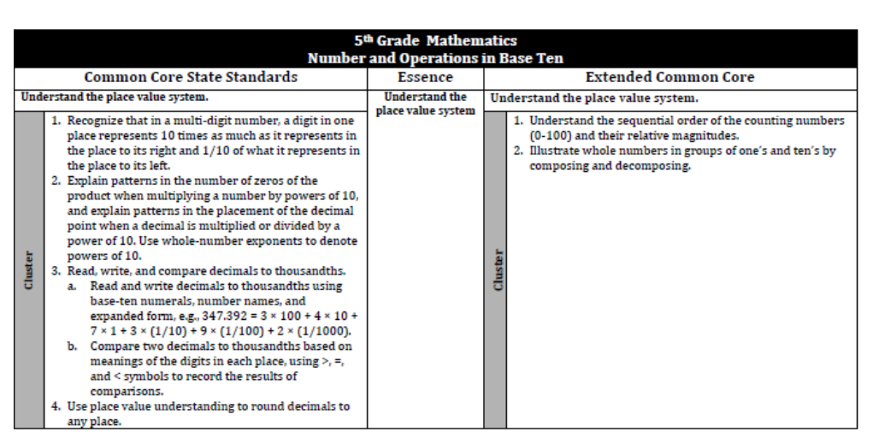
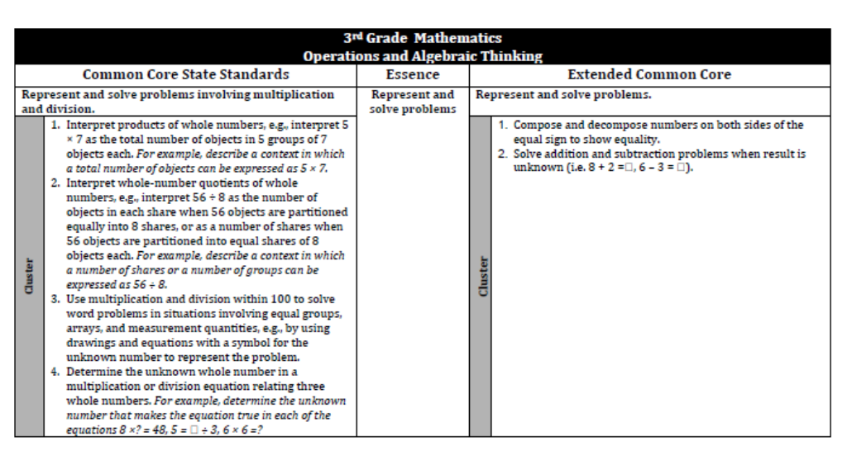
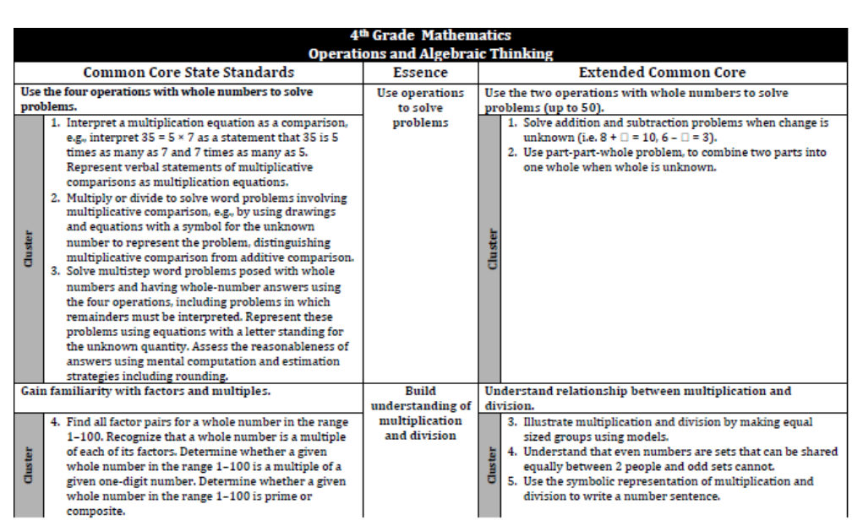
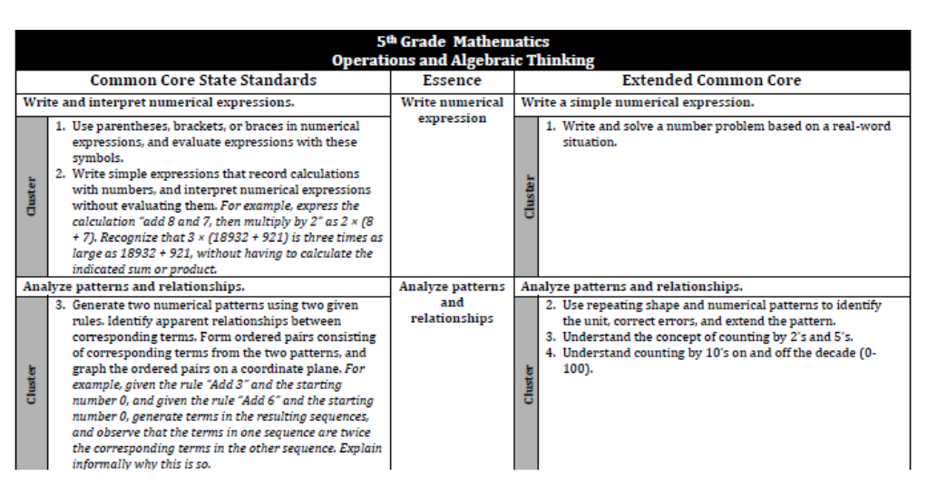

Lesson Procedures
Review (Links to Prior Knowledge, Anticipatory Set):
Students are exposed to text in all academic areas. The students will be exposed to numeracy skills throughout the math content the review is built into each lesson.
What the teacher will do:
1: The teacher will prepare the environment so all students have the AAC devices needed to optimize their participation.
2: The teacher will direct the lesson from the smartboard. Giving many opportunities for the students to participate and interact with materials.

Story Based lesson format is used.

Note: The teacher will divide the students into smaller groups to provide them with more individualize education and offer the students another chance for repetition of concepts throughout the week.

What the teacher assistants will do:
The teacher assistants at the beginning of the lesson will assist the students with the access to the devices. They will collect data to track the responses from the students.
Once the students are in smaller groups, the assistants will lead a small group and complete the activity planned for the smaller group.
Guided/Independent Practice
Guided practice: The teacher will present the lesson and utilize constant time delay to increase accuracy.
Independent practice: Each student has the opportunity to participate in the lesson by using the repeated storyline, answer questions and creating their own poem.
Assessment/Check for Understanding
The teacher will use comprehension questions throughout the lesson varying the type and or the amount of choices presented to the students. She will utilize constant time delay to increase the accuracy of the responses.
The students will complete activities related to the topic and will be assessed using the prompting levels.
Closure/Summary
Students will be assessed on individual IEP goals, objectives and/or comprehension questions.
Reflection  (after teaching the lesson) |  | Differentiation |  | Student Engagement |  | Data  Collection | Higher Level Question |  | Lesson Effectiveness
 |  | Low High  1 2 3 4 5 |  | Low High  1 2 3 4 5 |  | Low High  1 2 3 4 5 | Low High  1 2 3 4 5 |  | Low High  1 2 3 4 5
Comments |  | What would you do differently and what worked well?

Possible Math Activities:
- Create a pattern using a Spring theme (templates are on the next few slides)
- Create a pattern using the student’s name, see example to the side, use marker dots or textures instead.
- make a spring wreath
- complete a scavenger hunt - identifying patterns- template on slide 18

- work on Math iep goals

- Make a food pattern with items you may have (cereal, noodles, candy, pretend food, etc...)

